Run a web server in docker:

docker pull nginx:1.17.5

docker image ls

docker run --name my-nginx -d -p 8085:80 -v d:\docker-learn\html:/usr/share/nginx/html nginx:1.17.5

docker container ls

docker stop my-nginx

docker container ls

docker container ls -a

Output:

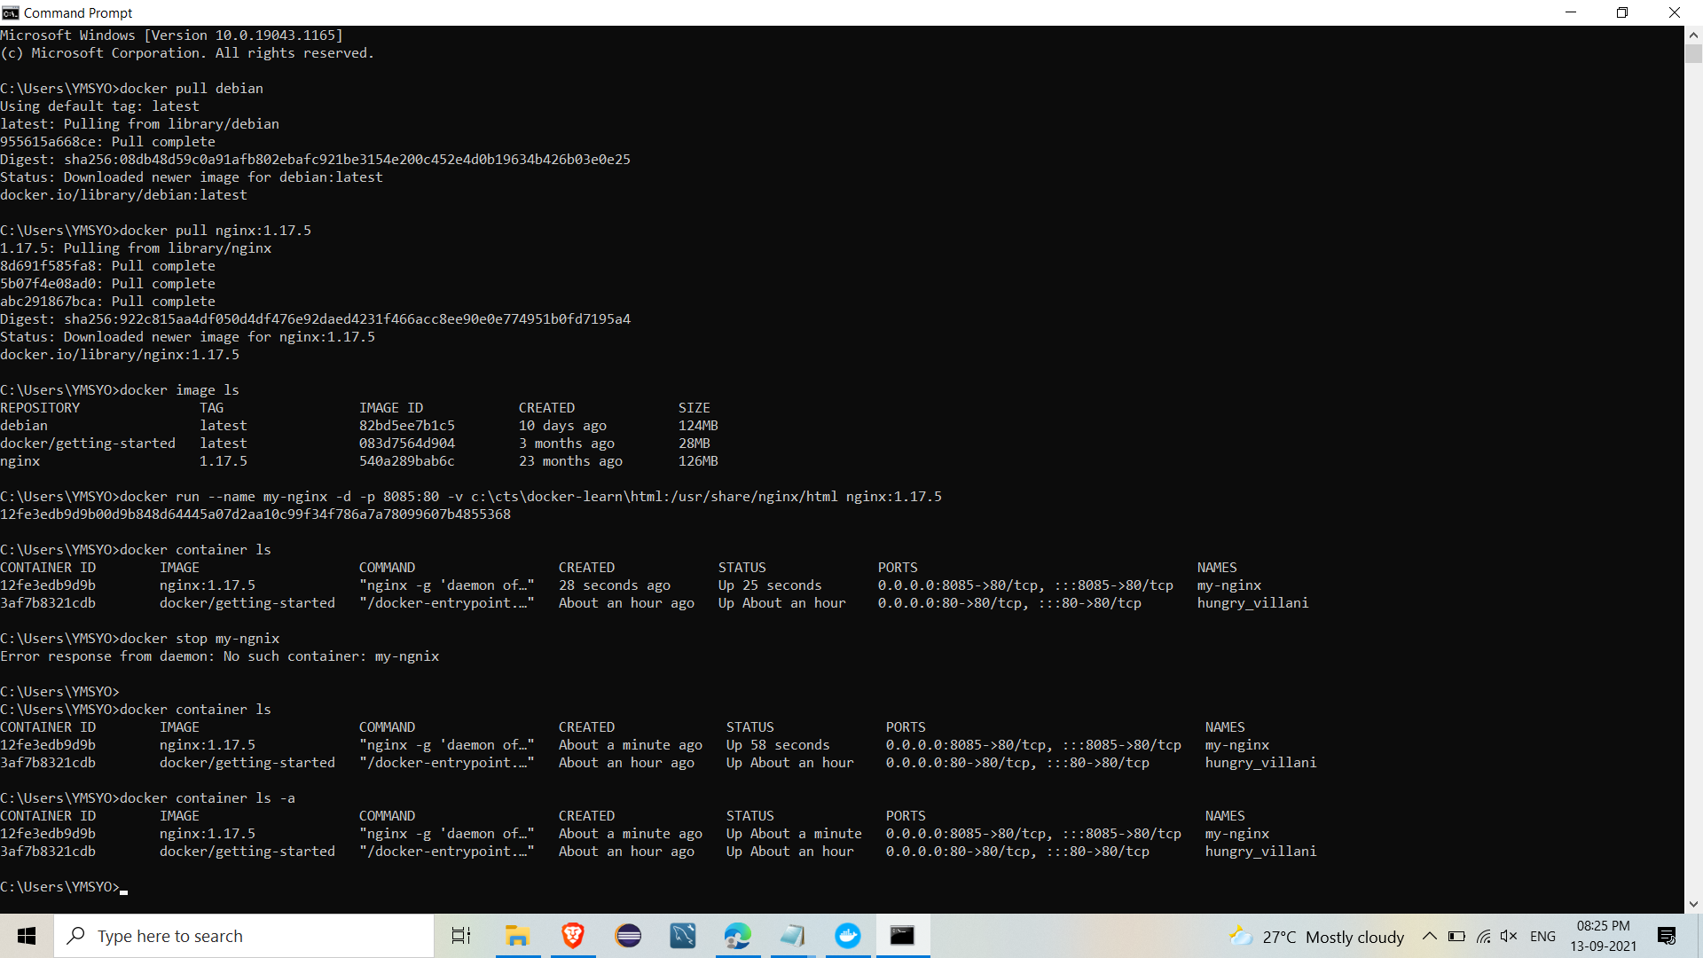

Start nginx using Dockerfile:

docker build

Output:

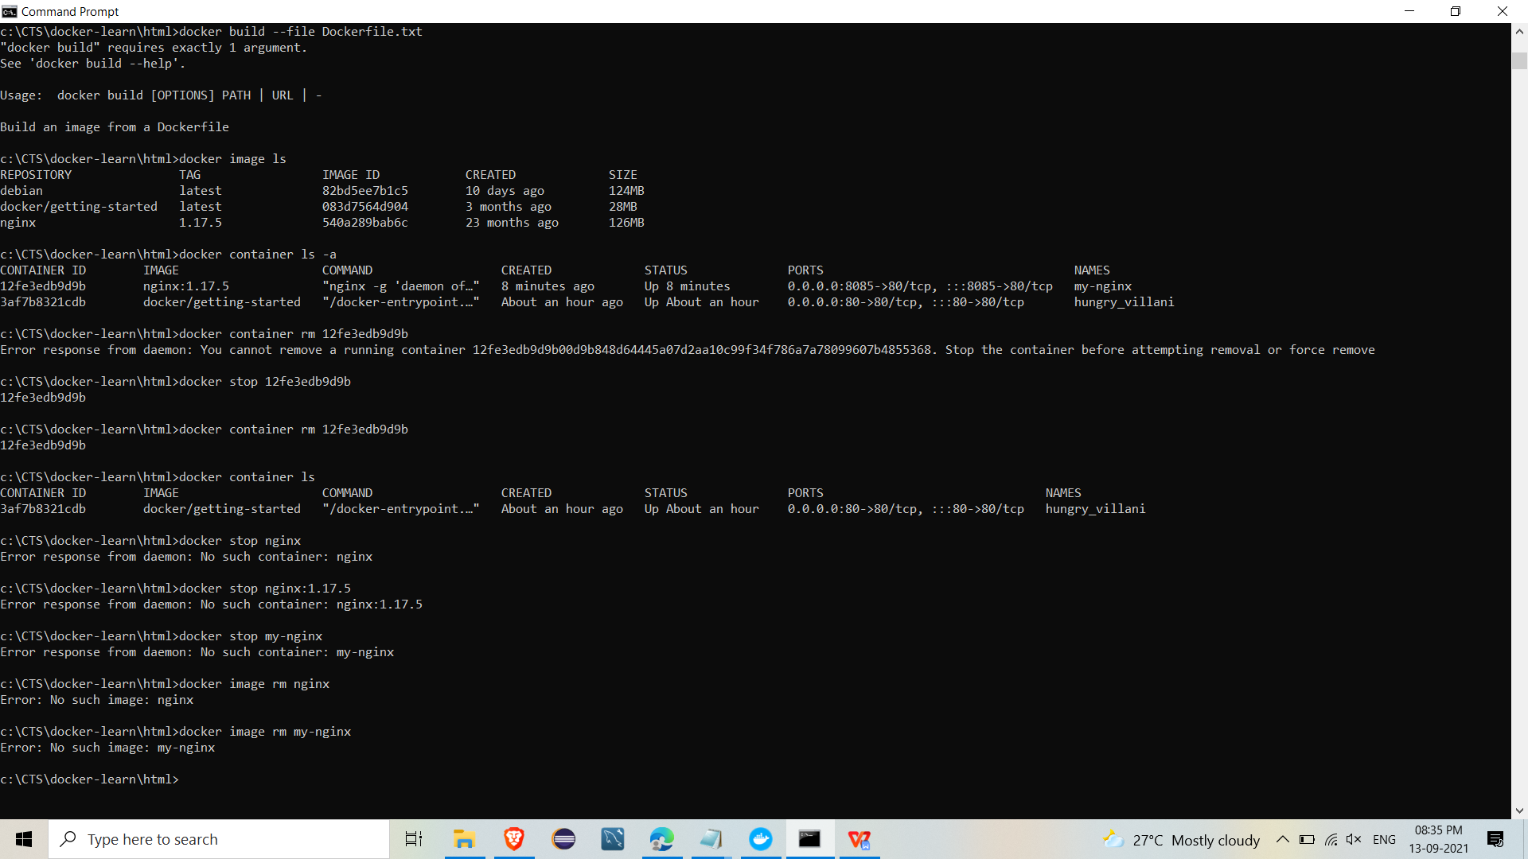

Removing images and container:

docker stop my-nginx

docker container ls -a

docker container rm 1507281f7688

Output:

